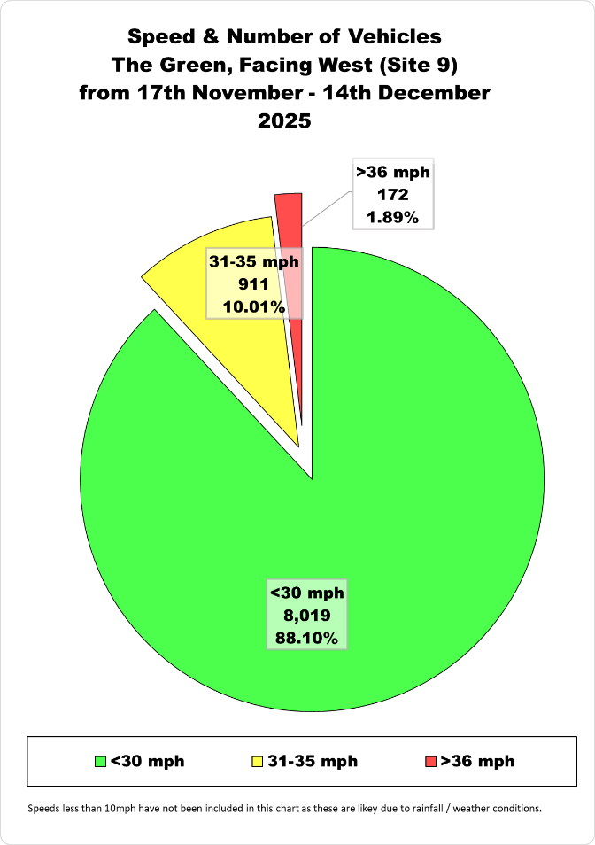

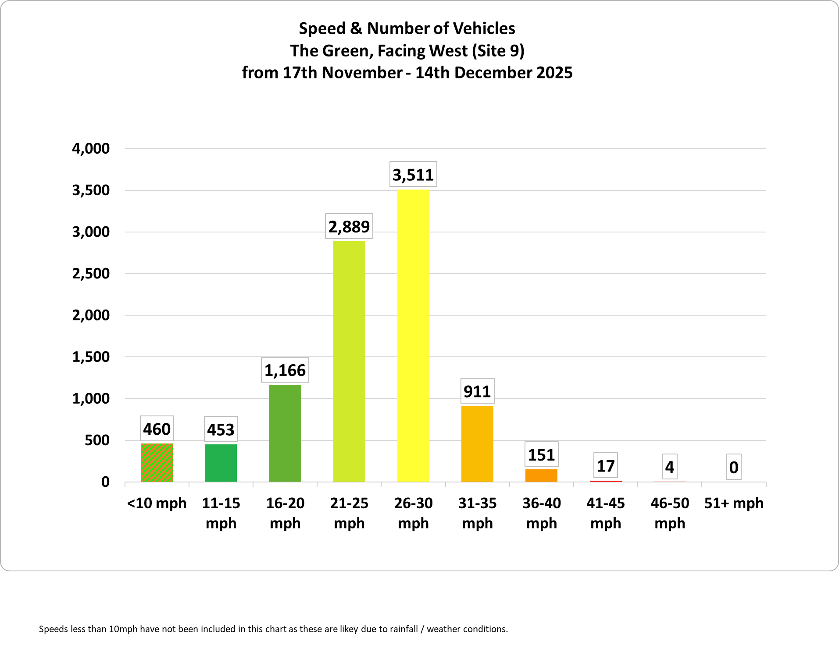
Speeds less than 10mph have not been included in this chart as these are likey due to rainfall / weather conditions.

