Surlingham Parish Council

Minutes of the Annual Parish meeting held on Tuesday 16th April 2026 in The Village Hall, Surlingham
(Subject to amendment until signed by the Chair at the next meeting)

Parish Councillors present Martin White (Chair), Pat Scowen, Dave Swinborne, Tim Mack, Gary Harris
District Councillor Vic Thomson – Left the meeting at 20:43pm
Also in attendance Charlotte Rust, Clerk
Members of the public (MOP) Two

26.59 Welcome from the Chair.
Councillor White opened the meeting at 20:17pm and welcomed all those in attendance.
26.60 To receive and approve apologies for absence.
Councillor Mummery sent his apologies.
26.61 To receive any declarations of interest from Members & consider requests for dispensation.
Councillor Mack declared at interest in item 9.1.2 (minute 26.67.01.02).
26.62 To approve the minutes of the Parish Council meeting held on 10th March 2026.
Councillor Scowen proposed for Councillor White to sign the approved minutes of 10th March 2026, seconded by Councillor Mack.
26.63 Adjournment for Public Participation.
A member of the public asked if Councillors had participated in the Butterfly trail organised by Friends of Surlingham School. Several Councillors and the Clerk had walked parts of the trail and commented how enjoyable it was.
Councillor Thomson gave an overview of his report; a full version will be available on the website:
- Preparations for the 3 Unitary Councils are happening.
- September 2026 a Joint Committee with County and District members will make plans ready for the new Unitary Council whilst shadowing after 2027 elections.
- Devolution talks will recommence after 8th May 2026.
26.64 Finance:
26.64.01 To receive Finance Report for 2025-2026.
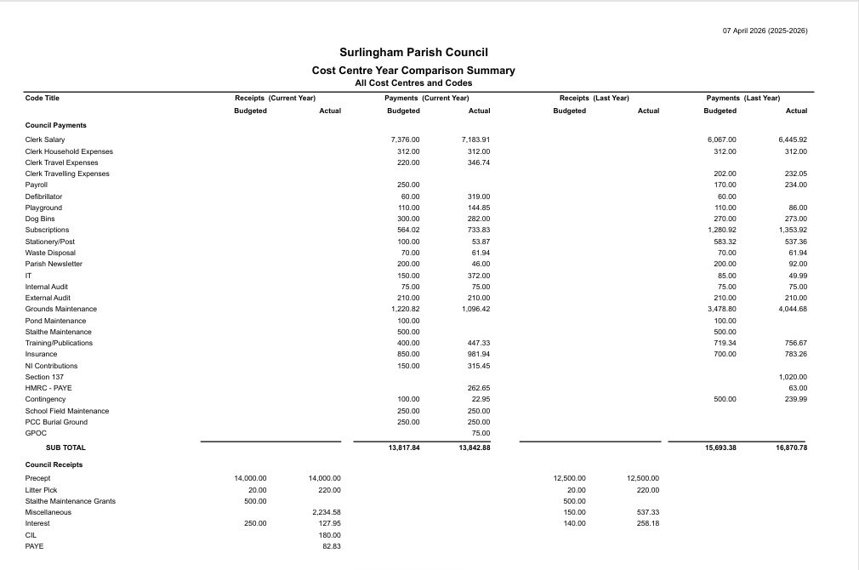

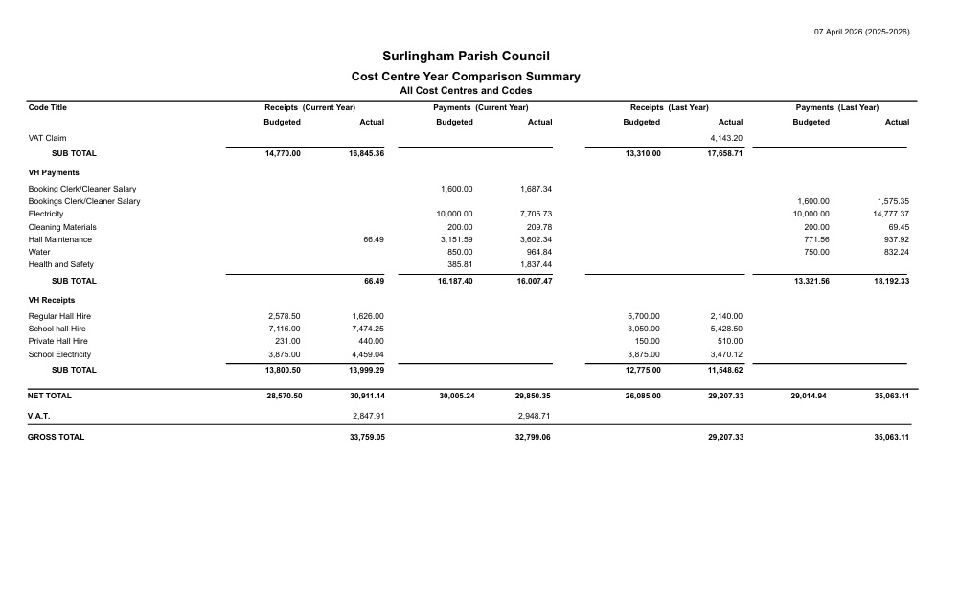

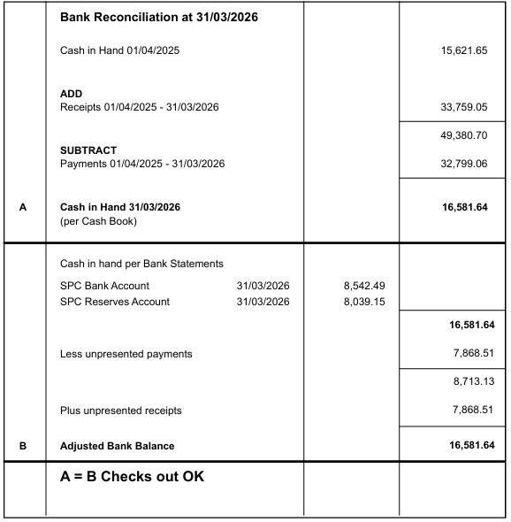
26.64.02 To receive the Bank reconciliation and Statement of Accounts as of 31st March 2026.

Councillor Mack proposed for the Chair and Responsible Finance Officer to sign the Bank Reconciliation dated 31st March 2026, seconded by Councillor Swinborne.
26.64.03 To note any receipts and approve payments as per April’s payment schedule.
FOR APPROVAL
 | DATE | EXPENDITURE | PAYMENT METHOD | TOTAL | VAT | P/R NO
Clerk | 15.06.26 | Apr expenses | BACS | £30.60 | £0.00
Clerk | 27.06.26 | April Salary & WFH | BACS | £659.70 | £0.00
HMRC | 15.06.26 | PAYE and Employers NI | BACS | £62.86 | £0.00
SNDC | 15.06.26 | Non domestic Rating demand | BACS | £0.00 | £0.00
 | 15.06.26 | Waste disposal | BACS | £61.96 | £0.00
Wave | 15.06.26 | Water 2026-2027 | BACS | £1,077.36 | £0.00
Parish Online | 15.06.26 | Website | BACS | £628.60 | £71.60
CAN | 15.06.26 | Silver Membership | BACS | £50.00 | £0.00
AAA Pest Control | 15.06.26 | Pest Control | BACS | £112.50 | £0.00
PVS Plumbing | 15.06.26 | Blocked urinal | BACS | £90.00 | £15.00
Norwich Gutter Cleaners | 15.06.26 | Clear gutters and clean windows | BACS | £206.50 | £0.00
TO NOTE PAYMENTS MADE OUTSIDE MEETINGS
Minuteman Press | 30.03.26 | Play Area designs enlarged | DC | £56.85 | £0.00 | P166
Yorkshire Power | 12.06.26 | Electricity | DD | £966.07 | £157.67
TO NOTE INCOME
Norfolk ALC | 12.03.26 | Payroll payment returned | BACS | £172.80 | £28.80 | P160
 | 27.03.26 | Hall Hire | BACS | £55.00 | £0.00 | R77
 | 23.03.26 | Hall Hire | CHQ | £18.00 | £0.00 | R78
 | 27.03.26 | Hall Hire | CHQ | £18.00 | £0.00 | R79
 | 27.03.26 | Hall Hire | CHQ | £18.00 | £0.00 | R80
 | 27.03.26 | Hall Hire | CHQ | £60.50 | £0.00 | R81
 | 27.03.26 | Hall Hire | CHQ | £20.00 | £0.00 | R82
 | 27.03.26 | Hall Hire and Electricity | BACS | £2,088.20 | £0.00 | R83
 | 30.03.26 | Hall Hire | CHQ | £67.50 | £0.00 | R86
 | 30.03.26 | Hall Hire | CHQ | £72.00 | £0.00 | R85
Councillor Mack proposed to approve April’s Payment Schedule, seconded by Councillor Harris.
26.65 Policies:
26.65.01 Disciplinary.
Councillor White proposed to approve the Disciplinary Policy, seconded by Councillor Swinborne.
26.65.02 Grievance.
Councillor White proposed to approve the Grievance Policy, seconded by Councillor Mack.
26.65.03 Internal Control Policy.
Councillor White proposed to approve the Internal Control Policy, seconded by Councillor Mack.
26.66 The Big South Norfolk Litter Pick 2026.
Councillor White will liaise with the school to arrange a route during Walk to School Week.
26.67 Planning:
26.67.01 Applications:
26.67.01.01 2026/0520 – Surlingham Lodge – Change of use of two holiday lets units (C1) into one dwelling (C3) with associated alterations including porch, solar panels, cartlodge, curtilage subdivision and access/parking.
Councillors unanimously agreed to submit a Neutral stance on this application as long as there are no concerns raised from neighbours.
26.67.01.02 2026/0604 – New Barn – Variation of condition 2 – Change to ground floor layout and fenestration changes and proposed material changes, from existing application 2023/1261.
In line with Surlingham Parish Council’s Standing Orders 13b, Councillor Mack left the meeting at 21:00pm, returning at 21:01pm.
Councillors unanimously stated there were no objections.
26.67.02 Decisions:
26.67.02.01 2023/0137 – Land North of The Green – Outline planning for a single, detached, private residential dwelling. South Norfolk District Council Approved with Conditions.
Noted.
26.68 To receive updates from individual Council Members (for information only).
None.
26.69 To receive any items for inclusion on the next agenda (for information only).
None.
26.70 To confirm date and time of the next meeting as Tuesday 12th May 2026 at 7.30pm in Surlingham Village Hall which is the Annual Parish Council Meeting.
Confirmed.

The public section of the meeting closed at 21:04pm.

26.70 Resolution to exclude members of the public and press under the Public Bodies (admission to Meetings) Act 1960.
26.70.01 To receive and consider the Clerk’s response to the Council’s proposed increase in contracted hours.
The Clerk clarified that Hall Management duties do not form part of her contracted role and currently represent approx. 85% of her working time. She provided further information in response to Councillors’ questions about the scope of these duties.
Councillors reconsidered the Clerk’s request and the proposal of 15 hours per week. It was agreed that Councillors will meet prior to the May meeting to discuss the matter in more detail and determine a proposal for consideration in May.

The meeting closed at 21:58pm.

