Surlingham Parish Council

Minutes of the Parish Council meeting held on Tuesday 10th March 2026 in The Village Hall, Surlingham
(Subject to amendment until signed by the Chair at the next meeting)

Parish Councillors present Martin White (Chair), Pam Wilson (Vice-Chair), Pat Scowen, Dave Swinborne, Tim Mack, Howard Mummery, Gary Harris
District Councillor Vic Thomson – Left at 19:59pm
Also in attendance Charlotte Rust, Clerk
Members of the public (MOP) Two

26.36 Welcome from the Chair.
Councillor White opened the meeting at 19:30pm and welcomed all those in attendance.
26.37 To receive and approve apologies for absence.
None.
26.38 To receive any declarations of interest from Members & consider requests for dispensation.
None.
26.39 To approve the minutes of the Parish Council meeting held on 10th February 2026.
Councillor Mack proposed for Councillor White to sign the approved minutes, seconded by Councillor Wilson.
26.40 Matters arising from February’s meeting, including Clerk’s report.
Matters arising:
- Beerlick’s Loke – no update.
- No85 bus service – the Clerk received an email from Charlie Poulter from Transport Made Simple Group: ‘Unfortunately there seems to have been a miscommunication on our end and I was not made aware of this consultation, otherwise I would have come down to the area to gather consultation answers from those uncomfortable responding online. I have put out a request to ensure this doesn't happen again. Unfortunately, the window for consultation responses has ended, however in light of this mistake I would be happy for you to write to me with any of your residents' concerns who have not been able to email us and input this into our consultation process with Norfolk County Council. Additionally in your email you mention people being unable to commute to work, if you could please let me know the specific times that these residents are working then I can pass this feedback on.’ The Clerk will post on the website and Facebook requesting feedback on the No 85 bus service.
- Willow Tree at staithe – Councillor Mack is waiting for the ground to dry before commencing works.
- FP1 wording – Mr Atkins has copied the Clerk into his correspondence with the Norfolk Trails team. The Clerk will update the council.
- Bench at Play area – The Clerk will publish a notice on the website and Facebook to ask parishioners whether they have any objections to the council removing the rotten bench, ahead of Councillor Mummery taking it away when he collects the tractor. He is waiting for the land to dry before commencing work.
- Received a response from Norfolk County Council regarding holding a meeting about flooding The Street/Cut Loke: ‘Works have been completed at this location to ensure that the drainage system is now functioning. The ditch and outfall on Cut Loke have been cleaned out by the landowner, and we have cleared out our drainage system which runs from The Green down to the outfall on Cut Loke. Norfolk County Council Highways Dept will continue to maintain our drainage system at this location in the future, which should ensure that the system continues to function effectively if the ditch and outfall on Cut Loke are maintained by the landowner. This approach should ensure that the system continues to function effectively. For these reasons, a meeting is not necessary with regards to this matter, as we consider the matter to be resolved with a plan in place to ensure the system continues to function.’ The Clerk is to contact Norfolk County Council again, copying in Councillor Thomson, to requesting re-jetting of the pipes as the area continues to flood.
Clerk’s report:
- Signed Electricity contract from March 26 - March 2028.
- Posted Norfolk County Council update regarding the triangle island and bollard at The Covey on website and Facebook.
- Forwarded thanks from parishioner to landowner who cleared the ditches at The Street.
- Grit Bin at Ferry Corner – emailed Norfolk County Council requesting the relocation.
- Cleaner given thank you gift and card.
- Councillor Mummery is meeting Steve Gildersleeve to take over moving the SAM2.
- Engaging your community training on 16th March, please let the Clerk know if you wish to book a place.
- Robin Goreham Internal Audit 2025/2026 fee confirmed - £80 no VAT.
- The council unanimously voted to hold Parish Council meeting in April after the Annual Meeting of the Parish to catch up on policy review.
- Invoices sent for February’s hall hire – Totalling £1,395.25.
- All necessary correspondence forwarded.
26.41 Reports from:
26.41.01 County/District Councillor, Councillor Thomson.
Councillor Thomson gave an overview of his reports; a full version will be available on the website.
- Devolution and Local Government Reorganisation is on hold until the May elections as Norfolk County Council cannot commit the next County Council to a deal.
- Village Clusters plan inspection ruling is due by the end of March.
- Internal Drainage Board and the RSPB are discussing plans for the sluice near Coldham Hall.
- RSPB is checking the Surlingham Staithe access.
- There are plans to raise the land in between Coldham Hall and the Sailing Club as it is current very low.
- Parishioners are encouraged to check their postal vote is valid before May’s elections.
26.41.02 Rivers, Ponds, Cycle/Footpaths.
The council would like to thank Mr Atkins for his hard work at Surlingham Pond. Councillor Mummery informed the council that the top railing behind the bench is missing, the Clerk is to ask Steve Gildersleeve if he can take a look.
26.41.03 Councillor White – Play Area inspection.
Councillor White confirm the inspections had been carried out and has forward the reports to the Clerk. He will fix the swing which is currently squeaking.
26.41.04 Parish Clerk – Traffic and SAM2.
The Clerk provided an overview of the previous two months data; the full report will be available on the website:
- Site 3 (Walnut Hill) - nearly 1000 more vehicles than previous period; Slight increase at all speeds but expected with increased traffic volume; Peak volumes on Tuesdays and Fridays.
- Site 5 (Surlingham Manor) - over 50% decrease due to road closures; overall reduced but high percentage under 25%; peak volumes on Tuesdays and Wednesdays.
26.42 Adjournment for Public Participation.
The Clerk to Surlingham Church and Poors Charity, informed the council that a parishioner who rents two allotment plots was approached by a councillor, in her capacity as parishioner, asking him to check with the Trustees regarding the structure on his plot. The Parish Clerk politely reminded Councillors that they cannot speak in their capacity as Councillor without approval from the Parish Council.
Surlingham Church and Poors Charity, thanked the council for seeking permission to allow a sculpture from the Friends of Surlingham School (FOSS) sculpture trail to be put at the play area.
Craig Neave, Chair of FOSS, introduced himself and thanked the council for considering FOSS’s requests.
26.43 Finance:
26.43.01 To receive the Bank reconciliation and Statement of Accounts as of 10th March 2026.
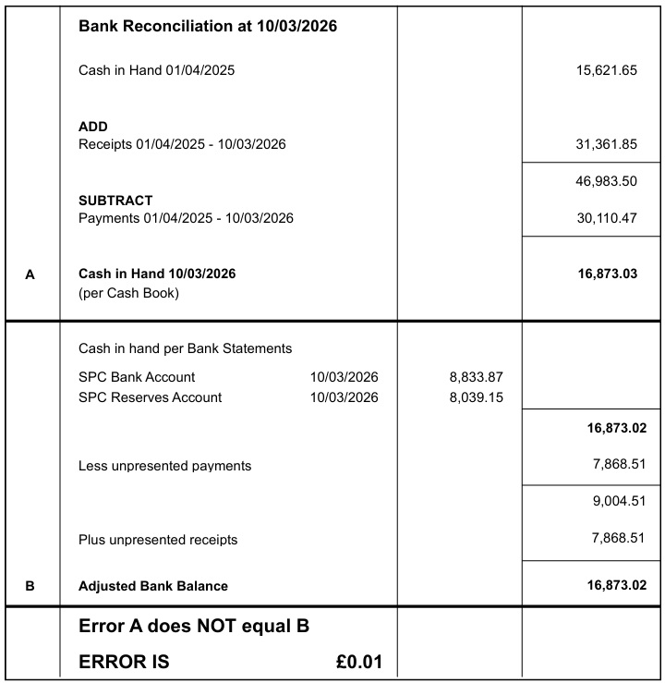

Councillor Mack proposed for the Chair and Responsible Finance Officer to sign the Bank Reconciliation dated 10th March, noting the 1p discrepancy and noting the Statement of Accounts, seconded by Councillor Wilson.
26.43.02 To note any receipts and approve payments as per March’s payment schedule.
FOR APPROVAL
 | DATE | EXPENDITURE | PAYMENT METHOD | TOTAL | VAT
Clerk | 11.03.26 | Mar expenses | BACS | £39.87 | £0.00
Clerk | 27.03.26 | Mar Salary and WFH with Feb back pay for hall bookings | BACS | £672.40 | £0.00
HMRC | 11.03.26 | Employer NI Contribution up to 5th April 2026 | BACS | £68.68 | £0.00
Orange Fox | 23.02.26 | Emergency Lighting repairs | BACS | £669.99 | £111.66
Norfolk ALC | 11.03.26 | Payroll 25/26 | BACS | £172.80 | £28.80
Yorkshire Power and Gas | 12.03.26 | Electricity | DD | £601.00 | £100.17
NPTS | 01.04.26 | Subscription 26/27 | BACS | £240.00 | £40.00
NPTS | 11.03.26 | Parish Online Mapping training | BACS | £28.80 | £4.80
TO NOTE PAYMENTS MADE OUTSIDE MEETINGS
ICO | 20.02.26 | GDPR subscription | DD | £47.00 | £0.00
Green Pastures | 16.02.26 | Cleaner gift voucher | DC | £25.00 | £0.00
John Lewis | 04.03.26 | Parking for scanning documents | DC | £2.00 | £0.33
Bookings Clerk/Cleaner | 03.03.26 | Additional holiday pay | BACS | £38.34 | £0.00
Amazon | 05.03.26 | Cleaning supplies | DC | £44.42 | £7.41
Amazon | 05.03.26 | Vacuum bags and paper towels | DC | £36.99 | £6.17
WI | 09.03.26 | Bench donation | BACS | £50.00 | £0.00
Minuteman Press | 09.03.26 | Scanning hall deeds | DC | £117.02 | £19.50
TO NOTE INCOME
 | 09.03.26 | Hall Hire | BACS | £72.00 | £0.00
 | 09.03.26 | Hall Hire | BACS | £20.00 | £0.00
 | 06.03.26 | Hall Hire | BACS | £80.00 | £0.00
 | 10.03.26 | Hall Hire | BACS | £40.00 | £0.00
 | 04.03.26 | Hall Hire | BACS | £10.00 | £0.00
Barclays | 02.03.26 | Interest on reserves | BACS | £20.30 | £0.00
 | 02.03.26 | Hall Hire | CHQ | £18.00 | £0.00
 | 02.03.26 | Hall Hire | CHQ | £27.00 | £0.00
 | 12.02.26 | Hall Hire | CHQ | £36.00 | £0.00
 | 10.02.26 | VAT Claim Oct - Dec 2025 | BACS | £347.13 | £0.00
Councillor White proposed to approve March’s Payment Schedule, seconded by Councillor Harris.
Councillor Scowen asked should the council ear mark funds to cover any potential hall deficit, the Clerk confirmed that this had been done as part of the 2026/2027 budget and there are £2,000 ear marked reserves.
26.44 Hall:
26.44.01 To consider and approve quote for hall land registration and hall valuation.
Hall Valuation - the Clerk requested quotes from:
- District Valuer Services – Provision of Valuation and Property Advice for Other Public Bodies (OPBs) – £1200
- A Chapman and Sons - £750+VAT
- The Norfolk Agents – no response
Registration of the Village Hall – the Clerk requested quotes from:
- Spire Solicitors - £1000 - £1750+VAT
- Nplaw - £397.50 (based on 5 hours work)
- Simpler Law – requires valuation before quote
- Cozens Hardy - £500+VAT (excluding disbursements)
- Wellers Hedley - £1000+VAT (excluding disbursements)
Councillor White proposed to proceed with registering the Village Hall with the Land Registry. Appointing A Chapman and Sons to conduct the hall valuation and Cozens Hardy to undertake the registration, seconded by Councillor Swinborne.
26.44.02 To consider FOSS’s request for free hall hire for School Fete 6th June.
Councillor White proposed to provide the hall free of charge for school fete, seconded by Councillor Mack.
26.44.03 To appoint new cleaner.
Councillor White and the Clerk provided feedback on the interviews held with the 2 applicants.
Councillor White proposed to appoint Steve Gildersleeve as the new cleaner, seconded by Councillor Harris. The council voted, by show of hands, FOR – 7 AGAINST – 0.
26.45 Play Area:
26.45.01 To consider FOSS’s request to use the play area as a location for its Easter holiday Sculpture trail.
Following Surlingham Church and Poors Trust agreement, Councillor Wilson proposed to approve the play area as a sculpture trail location, running from Monday 30th March – Friday 12th April 2026, seconded by Councillor White.
26.45.02 To receive an update on the public consultation.
The Clerk is to review the questionnaire as some councillors had trouble accessing/completing it.
The Clerk contacted Surlingham Garage, The Ferry House, Yare Valley Farm Shop and Teles Patisserie asking if it would be possible to have some hard copies of the questionnaire during the public consultation. Yare Valley and Teles Patisserie have confirmed they are happy to do so. She is also arranging for the draft designs of the refurbished play area to be enlarged to be shown at the hall during the consultation.
26.45.03 To receive an update regarding the removal of the tractor play equipment.
Please see minute 26.40.
26.47 Policies:
26.47.01 Emergency Plan.
Councillor White proposed for Councillor Scowen to set up working group amending the original draft Emergency Plan to bring to the council for review, seconded by Councillor Harris.
The working group members are Coucnillors’ Scowen, Harris, and Mack.
26.47.02 Data Protection.
26.47.03 Data Access Request Assessment/SAR Request.
26.47.04 Privacy Notice.
Councillor Wilson proposed to approve policies listed in minutes 26.47.02 – 26.47.04, seconded by Councillor Mack.
26.48 To consider the Big South Norfolk Litter Pick 2026.
The Clerk is to contact Mr Atkins to ask if he is willing to arrange a litter pick as he has done in previous years.
26.49 Planning:
26.49.01 Applications:
26.49.01.01 2026/0307 – Winbirri Vineyard – Steel framed agricultural building.
Noted.
26.49.01.02 2026/0447 – Caswell - Extension incorporating a porch. Removal of a carport and construction of a new boundary wall. New garage and outside covered area to the rear of the garage.
Councillor Scowen proposed the Clerk submit a neutral stance on South Norfolk Planning Portal, noting the objections of other commenters, seconded by Councillor Harris.
26.49.02 Decisions:
26.49.02.01 2023/3462 – Land East of New Road – Erection of three dwellings, associated access & groundworks. South Norfolk District Council Approval with Conditions.
Noted
26.50 Correspondence:
26.50.01 SPATS taxi refund.
The Clerk informed the Clerk that a parishioner had an issue with a SPATS cheque, and she guided him to the SPATS contact. The matter is now resolved.
26.51 To receive updates from individual Council Members (for information only).
None.
26.52 To receive any items for inclusion on the next agenda (for information only).
None.
26.53 To confirm date and time of the next meeting as Tuesday 14th April 2026 at 7.30pm in Surlingham Village Hall which is the Annual Meeting of the Parish.
Confirmed and it will be followed by a Parish Council meeting.

Councillor White closed the public section of the meeting at 21:00pm.

26.54 Resolution to exclude members of the public and press under the Public Bodies (admission to Meetings) Act 1960.
26.54.01 To receive and approve the Clerk’s appraisal including her request for an increase in hours.
Councillor White suggested that the Clerk issue policies or other reports a minimum of a week and half before the meeting summons is issued for councillors to forward on any comments/amendments to be included for review. All councillors agreed this was a good idea.

The Clerk left the meeting at 21:04pm and returned at 21:25pm.

Councillor White proposed that the Clerk’s contracted hours be increased to 13 per week, with a review after six months. He also requested that any overtime required for larger projects be submitted to the Council in advance for approval. The proposal was seconded by Councillor Scowen. Councillor White thanked the Clerk, on behalf of the council, for her hard work.
The Clerk thanked the Council and confirmed she would take time to consider the request.

The meeting closed at 21:32pm.

