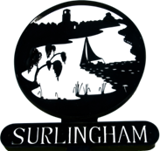
Surlingham Parish Council

Agenda

The ANNUAL PARISH MEETING of Surlingham is being held:

Date: Tuesday 14th April 2026
Time: 7.30pm, with refreshments being served from 7pm.
Place: Surlingham Village Hall

Charlotte Rust, Parish Clerk & RFO – clerk@surlingham-pc.gov.uk

- Welcome from the Chair
- To receive and approve apologies for absence.
- To approve the minutes of the Parish Council meeting held on 8th April 2025.
- Annual reports:
  - Chair of the Parish Council
  - County/District Councillor
  - Tornados Football Club
  - Luncheon Club
  - Padmaloka Buddhist Retreat
  - Surlingham Primary School
  - Off the Page
  - Church & Poor Charity
  - SPATS
  - WI
  - St Mary’s Surlingham
  - Forest School
  - Community Orchard
  - Coldham Hall Sailing Club
  - Bowls
  - Other reports

