Devolution.
Norfolk and Suffolk have agreed to the Devolution deal. There will now be a Mayoral Combined Authority.
This has set a Mayoral Election in May 26.
Mayor election May 2026
- Takes on powers immediately after election, in the same way that all other elected officials do
- The powers the Mayor will/can have are not straightforward and there will be some immediate powers, some that transfer later (for example Fire and Police will transfer over in 2027) and some are powers the Mayor could have in the future and so would need to negotiate with Govt about
- 4 year term
County Council elections May 2026
- 4 year term
- But, expecting government to reduce the term to two years as part of the legislation that they will lay to create unitary authorities – and they wouldn’t lay that until at least summer 2026
District council elections May 2026
- Norwich City Council has elections in May, for one third of members. Arrangements same as for County Council elections above
District council elections May 2027
- 4 year term
- Government will need to make a decision on whether they want these elections to go ahead or not, once they have made a decision on unitary
- They could extend the current term and essentially cancel these elections, which I think is probably the most likely thing to happen
- Or, they could let them happen and reduce the term to one year in the legislation they lay to create unitary authorities
Shadow authority elections May 2027
- 4 year term
Shadow elections will be for the new unitary authority areas. We will need to wait and see what government decide on the number of councillors any new unitary authority will have.
The Boundary Commission will likely need to carry out a review to determine the division areas of any new councillors, and they can’t do a review until the new entity exists which means after vesting day, so in practice it is mostly likely going to be elections using existing divisions as the starting point.
RPG
The Ministry of Housing, Communities and Local Government (MHCLG) has today launched the consultation on Local Government Reorganisation (LGR) proposals for Norfolk. All three proposals submitted for Norfolk will proceed to the consultation phase, which is open until 11 January.
The consultation includes:
- SNC’s proposal for a two council model
- The other districts proposal for a three council model
- NCC’s proposal for a single unitary authority
You can find a link to the consultation here: Consultation on Proposals for Local Government Reorganisation in Norfolk and Suffolk - Ministry of Housing, Communities and Local Government - Citizen Space
We encourage you to respond individually to the consultation and to encourage your town and parish councils, as well as residents, to also respond. Your views are important in shaping the future of local government in Norfolk.
NCC
The Government’s statutory consultation on Local Government Reorganisation (LGR) for Norfolk has launched today.
Three proposals are being considered:
· One unitary council for Norfolk, as proposed by Norfolk County Council
· Two unitary councils, as proposed by South Norfolk Council
· Three unitary councils, as proposed by the remaining six district councils
The consultation invites views on which option would best deliver strong and sustainable local government for Norfolk. It asks a series of questions about each proposal to help inform the Government’s assessment and decision.
Anyone with an interest in the future of local government in Norfolk — including town and parish councils, local partners, businesses, and members of the public — is encouraged to respond.
The consultation will run for seven weeks until Sunday 11 January 2026 and is available at GOV.UK - Consultation on local government reorganisation in Norfolk
Information and stakeholder fact sheets on the One Norfolk, One Council proposal can be found here – www.norfolk.gov.uk/onecouncil.
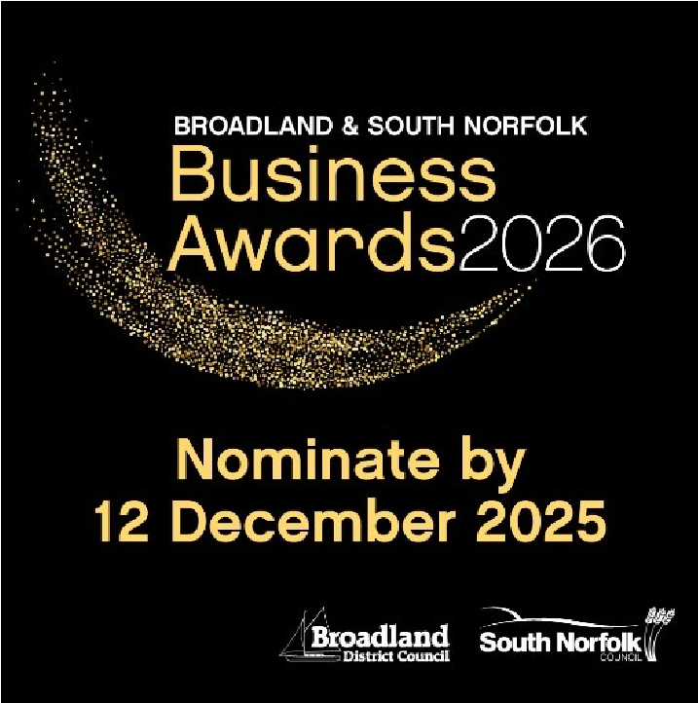
Business Awards 2026:

Nominations for the Broadland and South Norfolk Business Awards 2026 are now open.
Please can I ask that you encourage local businesses to nominate themselves in one or more of the business categories as well as encourage local residents to nominate their favourite Pub or Retailer of the Year.
Further details of the categories and the nomination forms can be found at:
www.southnorfolkandbroadland.gov.uk/businessawards
Compliance and Enforcement Reports:
You should have received an email last week informing you of some changes we are making to the monthly automated report that you receive in relation to Planning Compliance cases (Planning Enforcement) in the parish.
At present the content in the report is manually created and must be updated by the officer in addition to their daily work on the cases.
Historically, in some cases this has resulted in the updates being out of date.
We have therefore changed how we create the reports for you, while also improving our ability internally to monitor cases, plan future actions, improve workload management and performance reporting. In addition, the steps included in the report will include dates of when various actions were taken and a due date for the next action.
The report you received on Monday 3 November 2025 will be the last in the current format and I would recommend that you retain that report for your records, as the new report will only pick up actions since we implemented the new processes.

Bin Collection App:
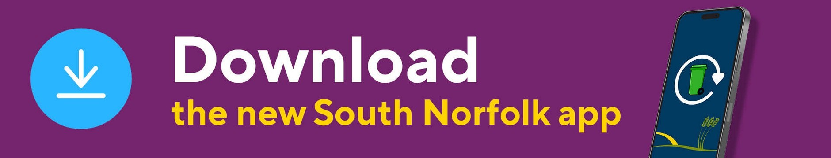
SNC have updated their bin app which is now available to download.
Users of the current bin collection app may have already received a notification directing them to the following webpage for more information and download links: www.southnorfolkandbroadland.gov.uk/sncbinapp
Please note, users of the existing app will not automatically receive the new app as an update - they will need to download the new app manually and delete the old version, which will be retired shortly.
The new app offers a more modern solution, replacing an increasingly outdated system that has seen no significant development since launch. Key benefits include:
- Personalised bin collection reminders and recycling guidance
- Push notifications that can be targeted by round, parish, or postcode – ideal for the forthcoming phased roll out of food waste collections or service disruptions
- New capabilities for reporting service issues (missed bins, flytipping, etc.), requesting a bulky collection or joining the garden waste service
- Direct links to book a visit to Norfolk County Council’s recycling centres.

We had our Town and Parish Council Summit latest meeting.
A lot was covered during the morning:
- LGR
- Planning and Compliance and Enforcement
- Winter Preparedness
- Police
- Support available for residents during the winter months
- Working together to get the most from a Unitary Authority We like to get feedback from people who attend.

