Devo and reorg
Lots of noise around elections without the proper context.
Mayor. If the Gov had stuck to the election delay, we could have signed the Mayoral Deal with the Investment Fund.
Now there is an election then we cannot commit the next County Council to a deal. They will do after the May election. We may see Devo again!
RPG. Consultation is closed on 11th!
Await their decision: 1, 2 or 3
Gov can make us adopt whatever Unitary number they decide
Deadline
May 28 is still the vesting day when Unitary replaces current 2 tier system.
Elections:
Each election costs well over 1 million pounds!!!!!!!!!!!!!!!
Time line: 4 elections in 2 years
May 26. County Council. In place for only 2 years!
May 27. District election. In place for only 1 year
May 27 Parish Councils
May 27. County Shadow council. 4 years
May 26 or May 28. Mayoral election
The County Council will keep the lights on for 2 years and turn them off on May 28.
The Shadow Council is essential for the Unitary. Setting it up and then running through initial period
Budget
February is the deadline for the Budgets.
We have received a 3-year settlement which is nice BUT
The amounts give us more decisions before February
Descending amount over 3 years
We change to Unitary in 2 years!
Very clear Rural Counties have done worse than the Metropolitan north
Details at next meeting when I report on final balanced budget
The Government has announced a new three-year local government funding settlement to reallocate resources towards councils with higher assessed levels of need.
The settlement provides limited detail on the treatment of existing special educational needs deficits. The money is part of the first multi-year funding settlement in over a decade, giving councils more financial certainty so that they can plan ahead. The Government’s provisional settlement moves funding from rural shire authorities towards metropolitan and urban areas.
The implications for Norfolk are currently being analysed and will be incorporated into 2026-27 budget planning, and the county council’s response to the Government’s consultation on the settlement that closes on 14 January 2026.
Question to MP
Why have the govt ignored the evidence of the fair funding review to retain the supposedly one off ‘recovery grant’ to gerrymander funds from rural areas to metropolitan heartlands?
Why have you allowed the Rural services delivery grant to be abolished?
Why should rural areas continue to subsidise SEND on a scale that dwarves the funding that metropolitan areas have to deliver?
Winter weather
Residents can also check this year’s gritting routes using the online map on the council’s website
(https://maps.norfolk.gov.uk/highways/maps/gritting.aspx)
If you’d want to report any gritting issues please contact the Report a Highways Problem section on the Norfolk County Council website
(https://www.norfolk.gov.uk/article/63696/Report-a-highways-problem)
Warm in Winter
Warm Welcome | Find Community Spaces Near You
Warm and Well - Norfolk & Waveney Integrated Care System (ICS
Norfolk Trails Public Survey
The council is seeking feedback to ensure that the future of Norfolk’s Trails aligns with the values and preferences of residents. A public survey is being conducted to gather community input, which will inform the long-term planning and improvement of the trails, with the aim of enhancing accessibility for all.
We welcome the views of our local councillors and are keen to hear from your residents – so please share the link to the public survey. The link to the survey is available here.

National planning policy framework consultation
The Government has launched a major consultation on a revamped National Planning Policy Framework. They say that the changes will help optimise land use through well-designed, higher-density development, simplified biodiversity rules for smaller sites - and fast-track good housing projects that meet national standards for energy efficiency.
The proposed measures aim to advance their objectives for economic growth, construction of 1.5 million new homes during this Parliament, and the achievement of clean power by 2030.
They also seek to establish a stable, rules-based system where developments meeting clear standards can move quickly from plans to construction.
A link to the consultation is available here. It closes on 10 March 2026.
Grit Bins
Can you please3 check your grit bins
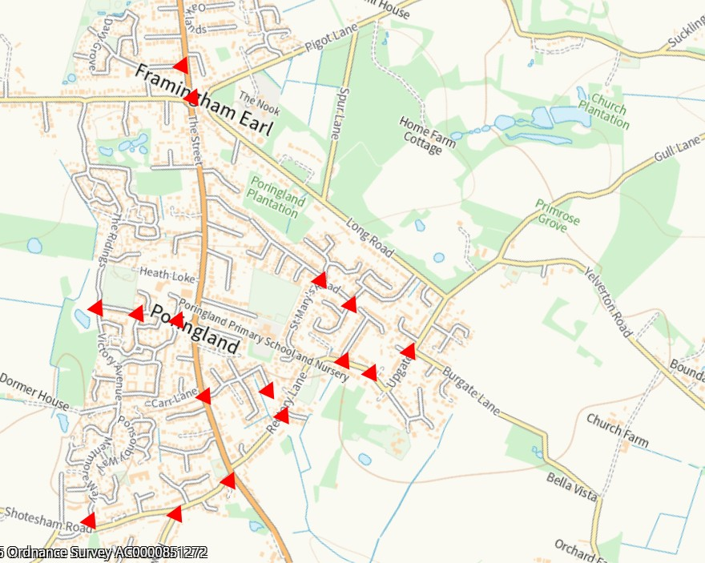
Support for abuse victims
The government has announced additional funding to bolster protection for domestic abuse victims, including almost £500 million for councils to provide safe accommodation and support services.

This includes an extra £19 million uplift that will help about 4,900 more households access refuge spaces or Sanctuary Scheme measures (which secure victims’ own homes), on top of £480 million already in local budgets. Framed as part of the new Violence Against Women and Girls strategy, the funding promises the largest ever crackdown on abusers.
Rural Business awards – nominations sought
Norfolk County Council and the Royal Norfolk Agricultural Association have announced that the Norfolk Rural Business Awards are returning for 2026. The 2026 awards were officially launched on 10 February at the Norfolk Farming Conference.
There are nine sponsored category areas aimed at showcasing a wide range of Norfolk’s best businesses, community groups and people. Each of the categories will have a specialist judging panel who will follow up with those shortlisted before making their final decision. The closing date is Tuesday 21 April.
Finalists will be invited to a ceremony at the Royal Norfolk Show in June where the winners will be unveiled. Winners will receive a trophy, a certificate, and be able to use Norfolk Rural Awards branding in their promotions.
Further details, including a list of the award categories and how to apply are available here www.norfolk.gov.uk/business/norfolk-rural-business-awards.
Half-term activities at Norfolk’s Libraries and Museums
DigiFest at Norfolk Libraries
DigiFest is part of our digital inclusion strategy with the aim of helping children develop essential skills and confidence while having fun at the same time. It is taking place in libraries across the county throughout February and has more than 130 events to choose from including stop-motion animation, learning basic coding skills, finding out about AI and trying out virtual reality headsets.
Everything in the programme is free but most need booking in advance - visit https://www.norfolk.gov.uk/digifest to find out more.
You can find out about all library activities in their events pages What's on in Norfolk Libraries - Norfolk County Council

Scams
Scam Alert - Emails claiming to be from NatWest
Scam Alert - Telephone cold calls claiming to be 'bank security'
Scam Alert - Fake Parking Charge Notice text & WhatsApp messages
Rogue Trader Alert - Doorstep Cold Callers claiming issues with properties' roof
Scam Alert – Investment scams
Cold Calling Alert - Telephone cold calls regarding spray foam insulation
Scam Alert - WhatsApp and Text Message family member scam messages
Scam Alert - Emails claiming to be from Barclays
Rogue Trader Alert - Doorstep cold callers offering roofing work
Rogue Trader Alert - Doorstep cold callers offering to lay tarmac

