Planning changes:
1.Just before last election we completed the GNLP and had a 5-year land supply!
New Govt told us we had to deliver 700 more houses per year!
Lost land supply. Important because we can control development when we have 5-year supply.
2. We must redo our Local Plan and we had a call for sites until 23rd march.
3. Clusters. We had a lot of 100+ developments around district and decided to look at smaller clusters in villages with schools. This was done solely in SNDC and not Greater Norwich.
The cluster plan and the clusters themselves have just been through an Inspection, and we expect the Inspectors rulings shortly.
Reorganisation to Unitary Council model
The switch to Unitary is April 2028 and there is a massive amount to do in that short term.
Devolution and Mayor
Mayor. If the Gov had stuck to the election delay, we could have signed the Mayoral Deal with the Investment Fund.
Now there is an election then we cannot commit the next County Council to a deal. They will do after the May election. We may see Devo again!
RPG. Consultation is closed on 11th!
Await their decision: 1, 2 or 3
Gov can make us adopt whatever Unitary number they decide
Deadline
May 28 is still the vesting day when Unitary replaces current 2 tier system.
Elections:
Each election costs well over 1 million pounds!!!!!!!!!!!!!!!
Time line: 4 elections in 2 years
May 26. County Council. In place for only 2 years!
May 27. District election. In place for only 1 year
May 27 Parish Councils
May 27. County Shadow council. 4 years
May 26 or May 28. Mayoral election
The County Council will keep the lights on for 2 years and turn them off on May 28.
The Shadow Council is essential for the Unitary. Setting it up and then running through initial period
The Govt is “minded to” delay the Mayoral election to May 28. Catch up!!!!!!!!!
Powers revert to Mayor
- The transfer of powers and funding from Whitehall, to enable decisions on jobs, skills, transport and housing to be taken in Norfolk.
- A multi-million pound investment fund for 30 years, to spend on local priorities
- Power to attract investment into Norfolk.
Budget
- At Full Council this month we agreed a balanced budget. Hard work
- For the first time in a very long time the Govt gave us a multiyear deal. We have had single year plans that do not allow for medium term planning.
- The first time we geta 3-year plan we only have 2 years left!
- Clear that Council Tax is the main stand of funding for local authorities
- Clear, by distribution of money Govt does not like rural authorities.
- Lost New Homes Bonus and the Rural Services grant
We have now been told our deal might change!!!!!!!!!!!!
Where the Budget Pressures Are
• Homelessness/Temporary accommodation demand continues to rise:
▪ 52 households (2024) → 69 (2025) → 85 (Jan 2026).
o Nightly/B&B budget rises to £890k.
- • Waste Services o Food waste collection mandatory from April 2026. Food Waste funding rolled into the settlement
No separate new burdens grant is provided. South Norfolk taxpayers will bear the full cost of implementing the new food waste collection requirements.
o No separate government funding provided – fully falling on the council.
• Inflation & Staffing o Pay inflation assumed at 3.5%, with all staff paid at least Real Living Wage £13.45/hr.
• Economic Growth o UKSPF (prosperity fund) and REPF (rural fund) have ended – leaving a gap in external funding.
Dog Fouling and Vehicle Anti-Social Behaviour
- Public Space Protection orders against vehicle anti-social behaviour and dog-fouling in place across both South Norfolk and Broadland.
- PSPO for Vehicle Related Anti-Social Behaviour applies to all publicly accessible roads and land across both districts and covers activities including anti-social driving, doughnuts, racing, car cruising and more.
- PSPO for Dog Fouling applies to all publicly accessible land and enclosed play areas across both district and requires dog walkers to clean up after dogs and dispose of appropriately as well as prohibits dogs from being in enclosed play areas.
- Dog fouling signage are available for Towns and Parishes, please contact: pspo@southnorfolkandbroadland.gov.uk
- Penalties apply for both PSPOs
For more information: Public space protection orders | Broadland and South Norfolk

Fly-Tipping and Waste Disposal
- We usually see an increase in improper waste this time of year. It is important to report any incidents if you identify incident of fly-tipping in your area.
For more information about fly-tipping and waste disposal:
Where's the Fly-tip? | Broadland and South Norfolk
Litter bins, dog bins and street cleaning (including dead animals) | Broadland and South Norfolk
Bins and recycling | Broadland and South Norfolk
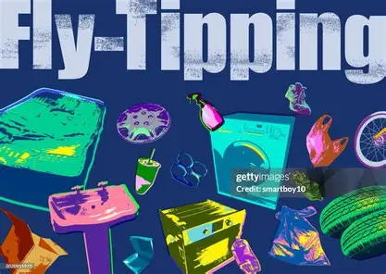
At a recent Cabinet Meeting our newly amended SNC policy on RIPA Regulation of Investigatory Powers, this is about covert surveillance conducted by the council, was passed unanimously.
As you know fly tipping is particularly difficult to detect but covert surveillance, where appropriate, enables prosecutions which otherwise would not have been possible.
Business awards
Please see all the finalists for each category of the Business Awards
Broadland and South Norfolk Business Awards finalists 2026 | Broadland and South Norfolk
SNC Litter pick:
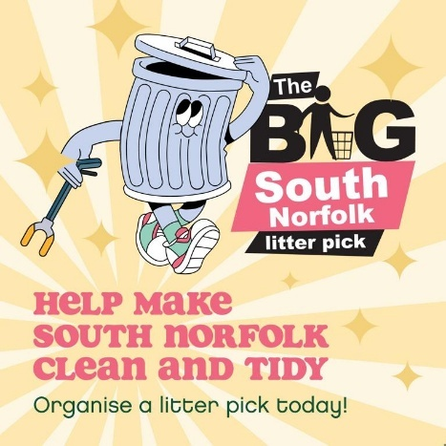
“The Great South Norfolk Litter Pick’ starts a month early this year as requested by many of the groups involved last year.
It launches on Monday, 16th February and runs until May 31st.
The financial remunerations have changed this year with £50 to every group that runs a pick. In addition five groups chosen at random with receive £500 .
Last year 52 groups participated, consisting of 767 volunteers, collecting 664 bags of litter (approximately 4,684kg).
Please see SNC website as from 16/2/26 for full details about how to apply to take part”.
Big South Norfolk Litter Pick | Broadland and South Norfolk
Recycling
Battery and electrical kerbside recycling scheme to launch in South Norfolk | Broadland and South Norfolk
Lithium-Ion batteries
Lithium-ion batteries are now embedded in an enormous range of everyday products, from vapes and mobile phones to tablets, toys, novelty gadgets and seasonal decorations. Their spread has accelerated alongside the rise of “fast-tech”; cheap, disposable electronics that, much like fast fashion, are designed to be used briefly, break quickly and then be thrown away. Many of these small items contain hidden lithium batteries, and when they’re binned rather than recycled properly, they pose a serious fire risk. Once crushed in bin lorries or waste-processing equipment, these batteries can ignite, causing dangerous and costly fires.
Vapes
Vapes continue to present a significant challenge within waste streams and street-sweeping collections. Poorly made with their embedded lithium-ion batteries creates a fire risk when they are incorrectly disposed of. In 2023, it was estimated that two disposable vapes were discarded every second in the UK, contributing substantially to hazardous waste levels.
Although disposable vapes were banned from June 2025, it appears that many disposable vapes continue to be sold but being marketed as rechargeable devices. The anticipated reduction in vape-related waste may not occur as quickly, or as significantly, as originally expected when the ban was announced.
The rapid rise in vape use meant that disposal routes didn’t catch up as quickly. Since Spring 2025, there has been a noticeable increase in high-street disposal routes from supermarkets to shops such as B&M, as well as vape stores themselves.
Communications Campaign
A targeted communications campaign was launched to address these issues.
- Guidance on safe disposal routes for vapes, including in-store take-back schemes and recycling centre drop-off points
- Promotion of in-store recycling options for power tools, such as those available at B&Q
- Advice for mobile phone and tablet disposal, including a safe data-deletion guide and messaging encouraging residents to sell or donate working devices to divert them from the waste streams.
Vape Collection Points
At the same time, NCC introduced dedicated vape collection points at recycling centres. NWP supported the launch by publicising the new service as part of the wider campaign.
In the first three months, the service collected just under 500 kg of vapes, with the average vape weighing approximately 26 g.
The last few months have seen two fires in Caister, one at the transfer station and a second at the recycling centres. A third at Dereham. It’s difficult to determine the exact cause, though its thought to be a lithium-ion battery.
Next steps
NWP is working with the GYBC communications team to strengthen vape-related messaging to residents, following the recent fire incident. NCC is progressing work on improved signage at Caister Recycling Centre, informed by the findings of the waste composition analysis.
Pop-up WEEE collection events and the delivery of guidance on safe disposal practices. We will continue to enhance county-wide communications, exploring paid for targeted comms. While maintaining active participation in national awareness campaigns, such as Recycle Your Electricals.
Sams
Scam Alert - Emails titled 'your photos and videos will be deleted'
Cold Calling Alert - Cold calls regarding spray foam insulation removal
Rogue Trader Alert - Doorstep Cold Callers claiming issues with properties' roof
Scam Alert - Fake DVLA text messages
Cold Calling Alert - Telephone cold calls regarding 'loft insulation'

