LGR:
The Government has chosen the three new Unitary Councils Option.

- Greater Norwich
- East Norfolk
- West Norfolk

Services continue as normal, in this transition period all Norfolk Councils will work together preparing information for the new Shadow Councillors who are elected in May 2027.

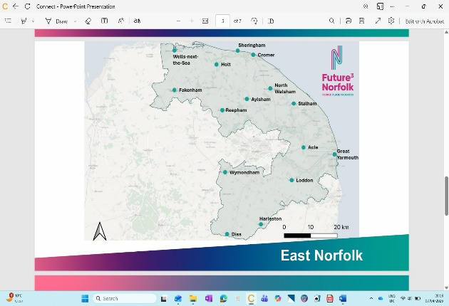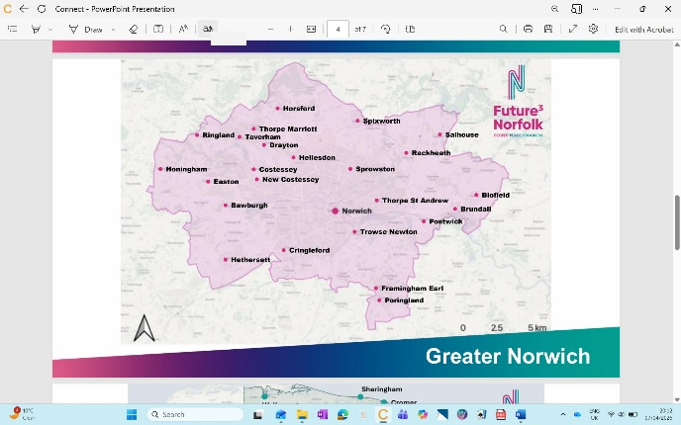

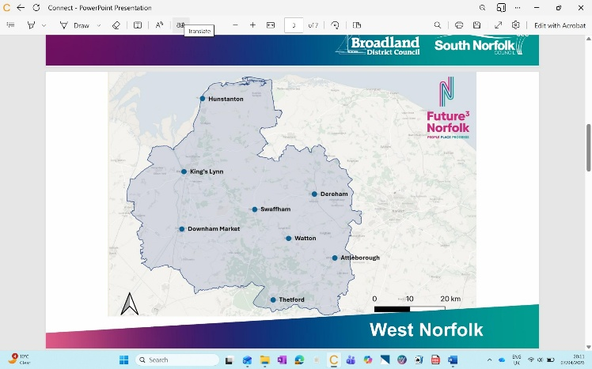
I will outline the current situation with some codicils.
May 6th 2026: We have an election for Norfolk County Council. NOT National
This will be the last ever election to the County Council
It will have some changes from the last time a NCC election was held.! Electoral Commission changes. Henstead explanation
There will be 84 Cllrs elected
The term will only last 2 years and will operate within some restraints. Cannot commit next admin
My 6th 2027: There will be a Shadow Council election
The term will last 5 years. 1 year to the vesting date for Unitary and then a 4-year term.
This will be election to The East Unitary, the West Unitary and the Greater Norwich Unitary. You in Greater Norwich
Greater Norwich will have 63 Cllrs
West will have 72 Cllrs
East will have 65 Cllrs
From around September 2026 until the Shadow elections there will be joint committees one for each new Unitary area.
Each committee will have members from the existing county and district councils with a total number of seats as:
Central 8, West 10 and East 12
Split will be 50/50 between County and District
The government have said only one election in May 2027. Ergo minded to cancel District (etc) and PC elections! Would be an election for 1 year!
Orders have not yet been laid in Parliament!
May 6th 2028 is vesting date and the Shadow member will become Unitary members.
May 7th 2027 Devolution discussion can start. Double Devolution???????????????

Surface Water Drainage Officers:

“The ditch walker” the Officer who held this post has moved on and we have now employed Karl Manning and Emma Rush (job share) as our new Surface Water Drainage Officers, supporting ongoing work on surface water management and community resilience.

They will focus on practical, on-the-ground inspection and engagement, including:

- Proactive land drainage inspections
- Investigating drainage issues reported to the Council
- Advising residents and riparian owners on watercourse maintenance
- Supporting the Flood and Water Management Officer with investigations
- Providing a visible, rapid presence within communities

Karl and Emma will be a visible presence across South Norfolk and key points of contact for early engagement on drainage matters. Their work also supports the Norfolk Strategic Flood Alliance’s education and awareness initiatives to improve community resilience.

If you have drainage concerns or wish to share local insight, please contact: surfacewaterdrainage@southnorfolkandbroadland.gov.uk

Councils celebrate National Award:

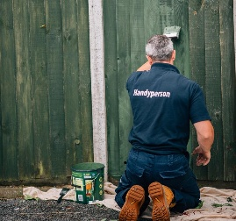
South Norfolk and Broadland District Councils’ Handyperson Service was named Handyperson Service of the Year at the prestigious National Healthy Housing Awards held at The Stoller Hall, Manchester.

The Handyperson Service provides practical support to residents by carrying out small repairs and adaptations in the home. This includes tasks such as fitting grab rails, installing smoke alarms, securing loose carpets, and other minor jobs that help people live safely and independently. The service is particularly valuable for older residents, those with disabilities, or anyone who needs extra help to maintain a safe and comfortable living environment.

South Norfolk handyperson service | Broadland and South Norfolk

LNRS and GNGIS:

Green Infrastructure Officer reviewing the Local Nature Recovery Strategy (LNRS) and the Greater Norwich Green Infrastructure Strategy (GNGIS).

These strategies are a collaborative approach to restoring and protecting biodiversity in Norfolk and Suffolk, and they are working with residents, experts, communities
and local authorities to design a better future for nature.

I have attached some links that will take you to more detail about the strategies and also some maps, where you can search for an area to see what they are showing.

There is a lot of information within these maps and I would suggest you have a good look clicking on different layers.
Local Nature Recovery Strategy (LNRS)
Norfolk Local Habitat Map
Green Infrastructure Strategy - Greater Norwich Growth Board

GNGI web app

Let’s Go:
This is a new visitor economy initiative which will be launching in the summer 2026.

It will connect people with their beautiful outdoors and local businesses.

- Encompass both the South Norfolk District and Broadland Districts together.
- One that could be adaptable come what may from devolution.
- A new Visit Economy website based on six walking areas.
- 30 proposed walking routes (GPS, GPX, Hard Copy Leaflets)
- Local business promotion.
- Social Media support through existing channels.

You may ask why we are doing this??

- Economic Value of tourism for Norfolk £3.6 bn
- FTE’s 54k plus
- Actual 72k plus
- 21% overall employment

lets.go@southnorfolkandbroadland.gov.uk

CAF Grant:

The two £500,000 pots, one for community projects and one for facilities, are now open for applications with the deadline for submission of applications the
16th August 2026.

This round for the community projects you can apply for anything from £1,000 to £40,000 although for the larger amounts you must have some match funding, this is explained in the ground rules I have attached.

https://onegovuk-my.sharepoint.com/personal/lisa_neal_southnorfolkandbroadland_gov_uk/Documents/Backup/New%20folder/Grants/CAF/caf-ground-rules-2026-amendments.pdf

The Community Facilities Grant (CFG) is provided to support and fund capital improvements to a community facility/building. These could be major refurbishments, adding solar panels, moving heat pumps etc. you can apply for between £10,000 and £50,000, once again for larger amounts there has to be some match funding, and I have attached a link with the ground rules for this pot.

https://onegovuk-my.sharepoint.com/personal/lisa_neal_southnorfolkandbroadland_gov_uk/Documents/Backup/New%20folder/Grants/CAF/cfg-ground-rules-2026.pdf

Planning:

We have received a number of consultations on planning reforms, although they are already at draft regulations stage, so I’m not sure how much notice they will take of any responses.

- Introducing a National Scheme of Delegation – Members will no longer be able to request an application is heard before the planning committee.
- Sets out in law
Which planning functions must be delegated to officers
Which functions are presumed to be delegated, subject to limited referral to committee
- Introduce a national maximum size for planning committees
- Public opposition alone is not a reason for committee referral
- Committee involvement should be based on planning significance
- Provides context and expectations for consistent national application

On top of the above we received a letter on the 17th April stating that any application for planning permission which is for development of 150 or more residential dwellings, and a certain floorspace for commercial buildings, and the council is minded to refuse, Officers now have to consult the Secretary of State before determining. This comes into effect on the 11th May 2026.

East Pye Solar:

We have received notification of the notice of acceptance and an application for a Development Consent Order for the East Pye Solar project.

This will now go before an Inspector for a hearing where he will make the decision.

Anyone can now register if they want to make a comment to the Inspector or listen to the hearing.

Attached are details regarding this, including the site map which shows how large the project is (1,212.3 hectares):

East Pye Solar - Project information

Have your say guide - Registering to have your say about a national infrastructure project

